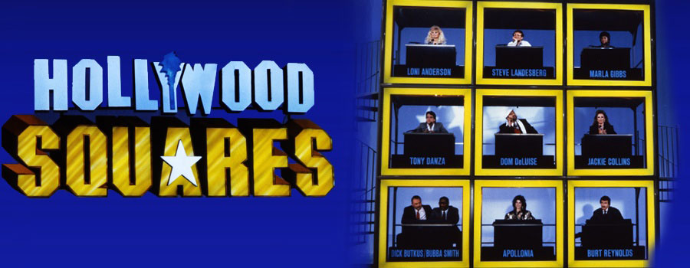

# Description

***Hollywood Squares*** is American game show in which two contestants play tic-tac-toe to win cash and prizes. The "board" for the game is a 3 × 3 vertical stack of open-faced cubes, each occupied by a celebrity (or "star") seated at a desk and facing the contestants. The stars are asked questions and the contestants judge the veracity of their answers in order to win the game.

# Rules

Although there have been variations over the years in the rules of and the prizes in the game, certain aspects of the game have remained fairly consistent.

Two contestants, almost always a woman playing **Os/naughts** (called *circles* in the show) and a man playing **Xs/crosses**, took turns picking a star and following the traditional tic-tac-toe strategies for which square to select. The star was asked a question and gave an answer. The contestants had the choice of agreeing with the star or disagreeing if they thought the star was bluffing. If the contestant was right, he or she got the square; if the contestant was wrong, the other contestant got the square, unless that caused the opponent to get three in a row. In that case, the opponent had to win the square on his or her own. A player also won by getting five "Xs" or "Os" on the game board (thus preventing draws).

On rare occasions, a star would not know the correct answer to a question or be unable to come up with a decent bluff. In such instances, the contestant would be offered the chance to answer the question to win or lose the square as above. Usually the contestants declined, in which case they incurred no penalty and the same star was asked another question.

# Requirements (broken up into “needs to” and “would be nice”)

It *needs to* have some sort of a graphical user interface. It *would be nice* to have animations and sound. It *needs to* have a tic-tac-toe back end that will handle that aspect of the game. It *would be nice* to have a computer opponent. There will *need to* be a moderator who asks questions and decides if your answer is correct. The will *need to* be a method of storing the trivia questions with both correct and incorrect answers. There will *need to* be some sort of algorithm for deciding whether to present a true answer or a false answer.

# Description of the program

Start with a **title screen** including **options** and **rules**. Once a game is selected the **board** will need to be drawn each square will get a **celebrity**. There will be a **moderator** off to the side. The **player** whose turn it is will click on the square that they want. Then a **question** will be displayed followed by an answer from the celebrity. The player will then get the opportunity to decide if this is true or false. If the player answers correctly the status of that square (on the **tic-tac-toe board** in the model) will be changed to represent the current players symbol (X/O). After each successful change the board will be checked for a winner (either a straight line or five of a kind to prevent draws), If there is no winner it will revert to the following player so that he/she can may select a square, be asked a question, be presented with an answer so that they can get a chance at that square and so on until there is a winner. After there is a winner there will be an **end sequence** and the option to play again.

# Objects

## GUI

TitleScreen

Options

Rules

Board

Person

EndSequence

## Back End

Player

Question

TicTacToeGame

TicTacToeBoard

# Sample graphics from other Hollywood Squares games

